Computer Workshop 1.1: Hidden Assumptions
Roos & Pinard
Last updated: 2024-08-14
Table of Contents

Workshop Structure
As always, we are using the workflow below to structure the workshops:
- Formulate a research question.
- Perform exploratory data analysis [Focus of today].
- Identify any hidden assumptions [Focus of today].
- Fit an appropriate model.
- Diagnose the model and check assumptions.
- Summarise the results.
- Interpret and provide inferences.
We covered steps 2 and 3 in the previous workshop but we’ll expand your toolkit for doing so today suing data visualisation.

Learning Objectives
- Learn how to use the R package ggplot2 to do data visualisation.
- Consider what constitutes an effective visualisation versus an ineffective one.
- Learn some techniques to make your figures more visually appealing to an audience.
These skills will be used throughout the course.

Introduction to ggplot2
ggplot2 is an implementation of the “Grammar of Graphics,” a framework for data visualisation. It allows you to build plots layer by layer, starting with a base plot and then adding additional elements such as scales, themes, and geometries. Familiarity with ggplot2 is occasionally asked for by employers; we’ve even seen job adverts from companies such as Spotify listing this an an essential criteria.
It is important to note, however, that ggplot2 is not the only way to create visualisations. It’s just an increasingly preferred one. Many of the figures you will make on this course can be near-perfectly recreated using the visualisation framework offered by base R. We simply prefer ggplot2 as we feel it is a more intuiative way to create figures; indeed, nearly every single figure you have and will see on this course were produced in ggplot2.

Load the data
For the first part of this workshop, we’ll be working with data on the Amazon river dolphin, or the boto (Inia geoffrensis - I wonder if the dude who named it called it after their friend Geoff…). Specifically, we’re interested here in seeing if there is sexual dimorphism in asymptotic length (i.e. once an animal has stopped growing) between females and males. As always, before we do any analysis, we need to ensure there is nothing weird in the data. In workshop 1 you did this by using simple summary statistics (e.g. mean()). While doing so is useful, complimenting this with data visualisations is really powerful.
Start by downloading the data from today’s practical folder, called boto.txt.
Go through the same steps as yesterday to load in your data; create a new script in RStudio, set your working (e.g. setwd("H:/BI3010/workshop2")), then load the data:
boto <- read.table("boto.txt", header = TRUE)
Given how easy it is to do, let’s do a quick summary() and str() to see if anything stands out:
summary(boto)
str(boto)
If nothing immediately seems off, we can continue.

A simple plot
We’ll build this figure up slowly, one layer at a time, to make the fundamental philosophy of ggplot2 clear. To begin with, we can simple make a “ggplot”:
ggplot()

Cool… A completely empty canvas. Well, it shouldn’t really come as a surprise that there’s nothing in this figure. For starters, we haven’t even told it which dataset to use. Let’s correct that now:
ggplot(boto)

Still nothing. What we’re missing here is where we tell ggplot2 a couple of things. First, we need to say in what form we want to the data to be shown. Do we want points? Or lines? Or errorbars? Secondly, we need to say which specific data, or “aesthetics” (shortened to aes() in ggplot2), we want shown and where. Do we want length included? On the x or y axis?
Let’s have length be on the y-axis and drought be on the x-axis. And the form (or geometry) that we want this data to be shown will be as points:
ggplot(boto) +
geom_point(aes(y = length, x = drought))
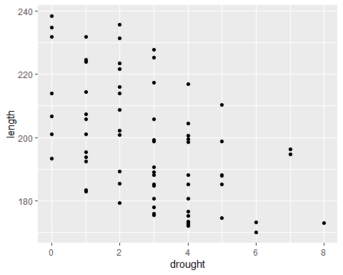
Now we’re getting somewhere. From an early data analysis perspective, what have we already learnt just from the quick summary stats and from this figure?

Question Set One
- What variables do we have available to us?
- How many observations/samples do we have?
- Is the relationship between boto length and number of drought years likely to be positive, neutral, or negative?
- What range of lengths do boto dolphins reach at maturity?

Increasing the complexity
The above figure is great. It’s simple and clear (though a bit ugly - we’ll come back to that later), but how would we include a categorical variable like sex? Can we just copy our code from above and replace drought with sex? Let’s see:
ggplot(boto) +
geom_point(aes(y = length, x = sex))
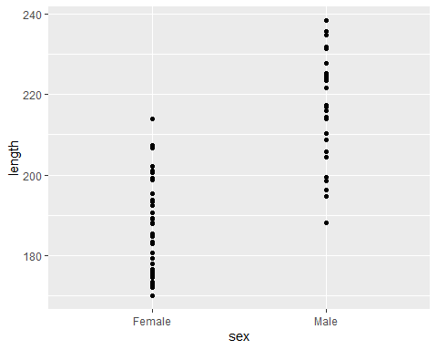
Kind of? It’s a bit hard to see the spread of data for each sex. A better way to show this is to use some sort of tool which will show help the reader understand the range of length for each sex but also how the data is spread. There are two common options people use for this; boxplots and violin plots. It’s trivially easy to swap between these, because all we need to do is change the geometry function from geom_point() to either geom_boxplot() or geom_violin():
# Boxplot
ggplot(boto) +
geom_boxplot(aes(y = length, x = sex))
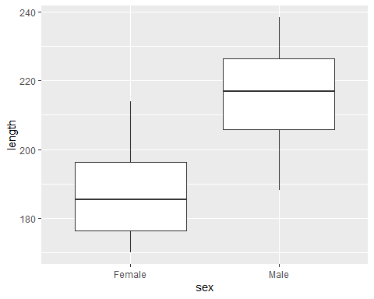
# Violin plot
ggplot(boto) +
geom_violin(aes(y = length, x = sex))
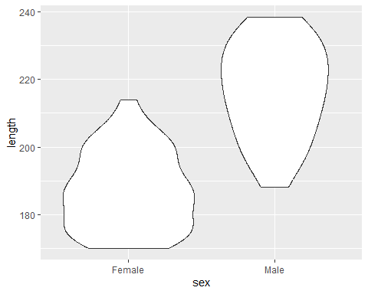
Both of these present the same information in different ways. The boxplot uses boxes and lines to indicate the range, the first and third quantiles and the median. Conversely, the violin plot also shows the spread of data but by creating density plots which are mirrored. Boxplots have a long history and use in science, but people are increasingly using violin plots, simply because they’re more transparent than boxplots.
With either boxplots and violin plots, it’s fairly common that people will add the data points to the figure as well - to really hammer home the spread of data. But we’ve seen before that using geom_point() basically gives us a line of points that doesn’t help us understand the spread at all. An alternative is to use something called “jiterring”. When we jitter points, we add a small random value to either or both the x and y position to spread the data out a little bit. With our boto data above, we wouldn’t want to add anything to y (as we’re interested in the length of the dolphins, so we don’t want to mess that up) but we can happily add something to x (or sex). To do so, we can use geom_jitter() but we want to specify that “noise” should only be added to x and not y. Here’s how we do that:
ggplot(boto) +
geom_violin(aes(y = length, x = sex)) +
geom_jitter(aes(y = length, x = sex), height = 0, width = 0.1)
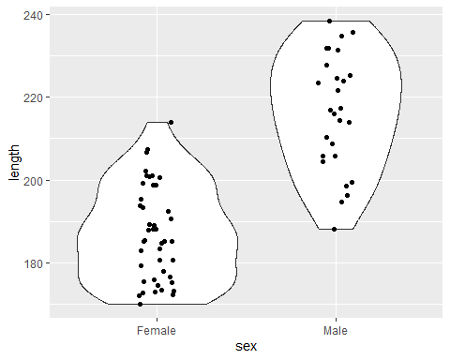
We don’t add the height = and width = arguments to aes(), as aes() is used to reference parts of the actual boto dataset. Whenever we want to make changes to a geom_ that are not related to the data, we do so outside of aes().

Optional: Recreate this figure
Have a look here, specifically at the layers section. Using this try to recreate the following figure (note you will be prompted to install a package. Type 1 and enter in the console to do so):
